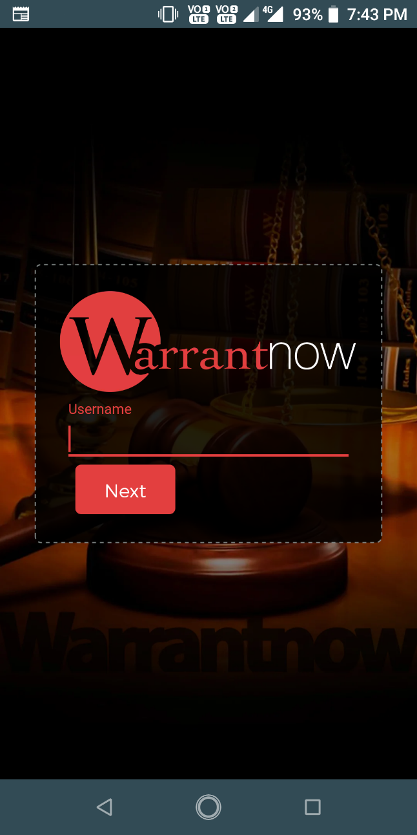
WarrantNow 2.0 Android App
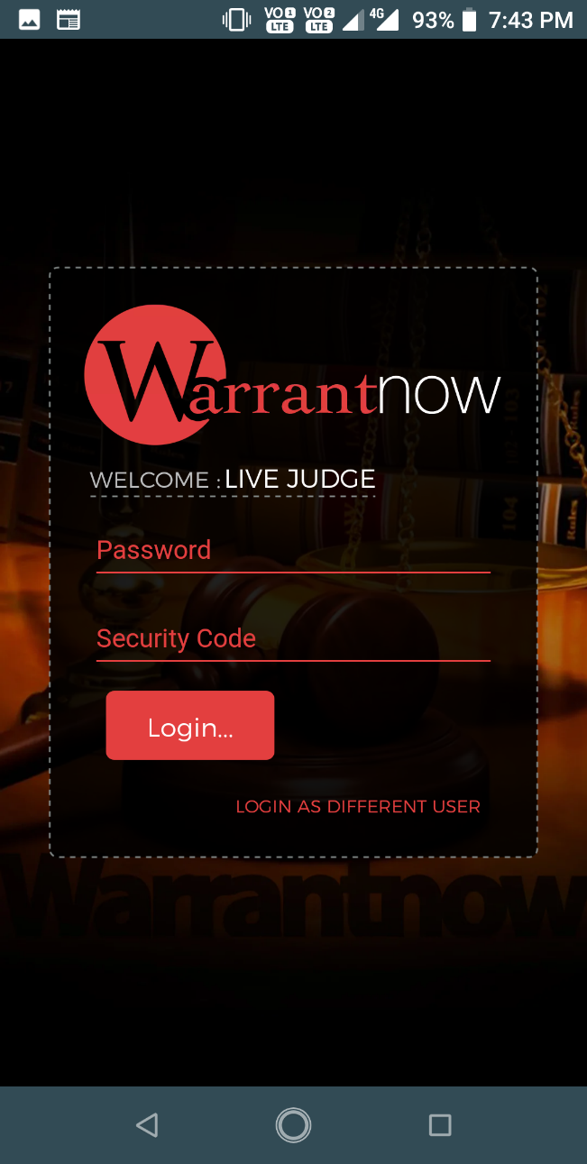
Login Screen 1
If user id is not valid or the user type is not authorized to use the app then show an error message.
Login Screen 2
If user enter wrong password or security code then show an error message.
If user enter wrong password or security code more than 5 times then lock the user id and show appropriate message
Clicking on ‘Login as different user’ redirect to login screen 1.

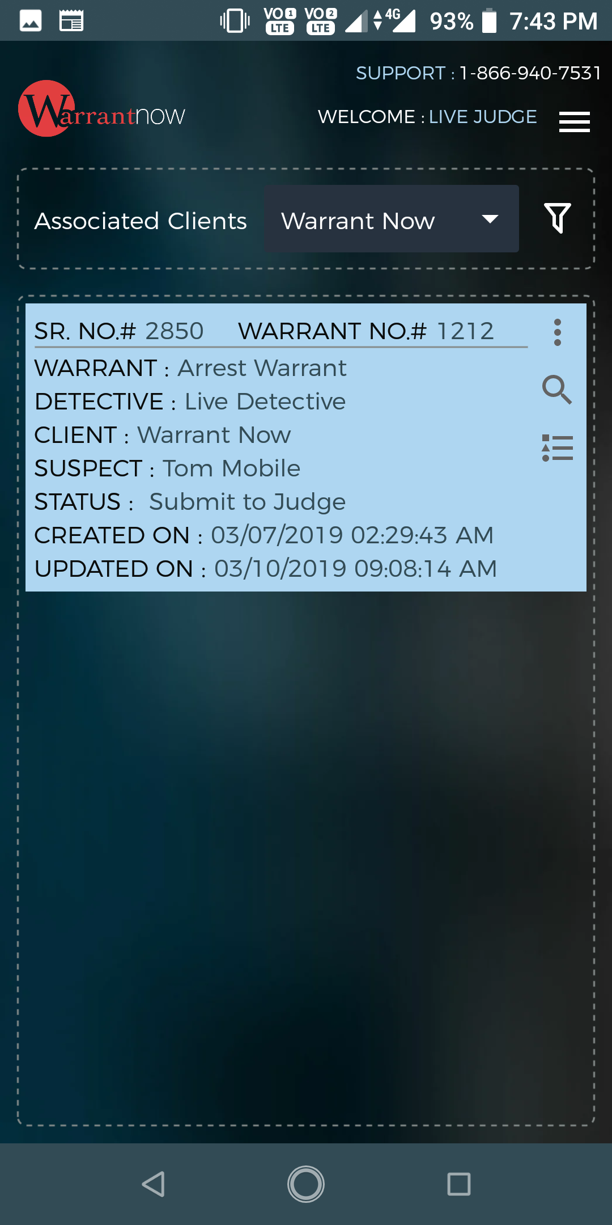
Menu

Search Warrant
Preview

Preview

Warrant Trail
Dashboard & Warrant list
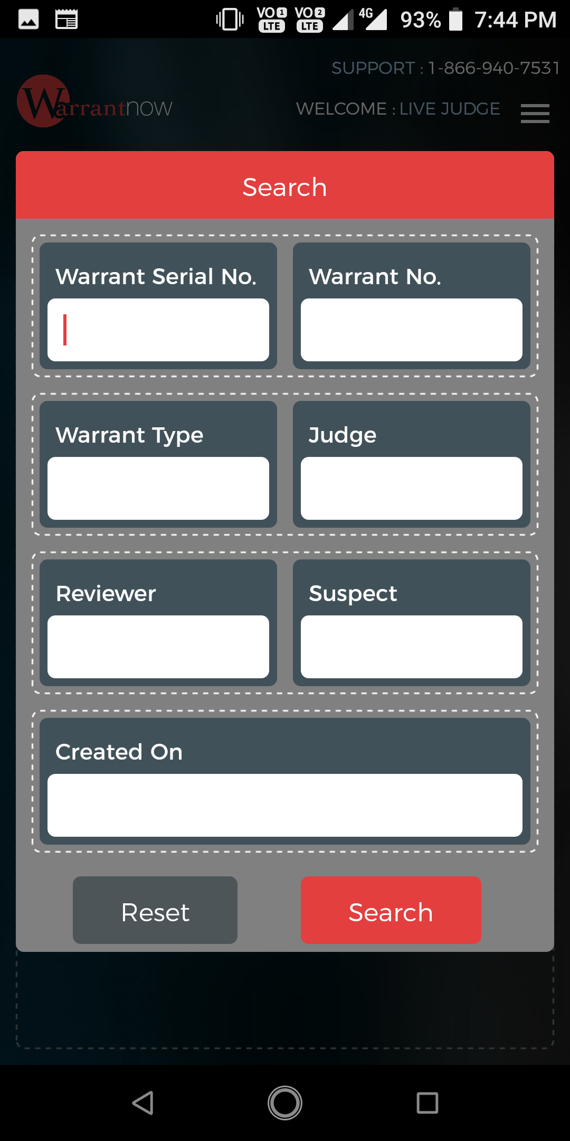

Search Warrant

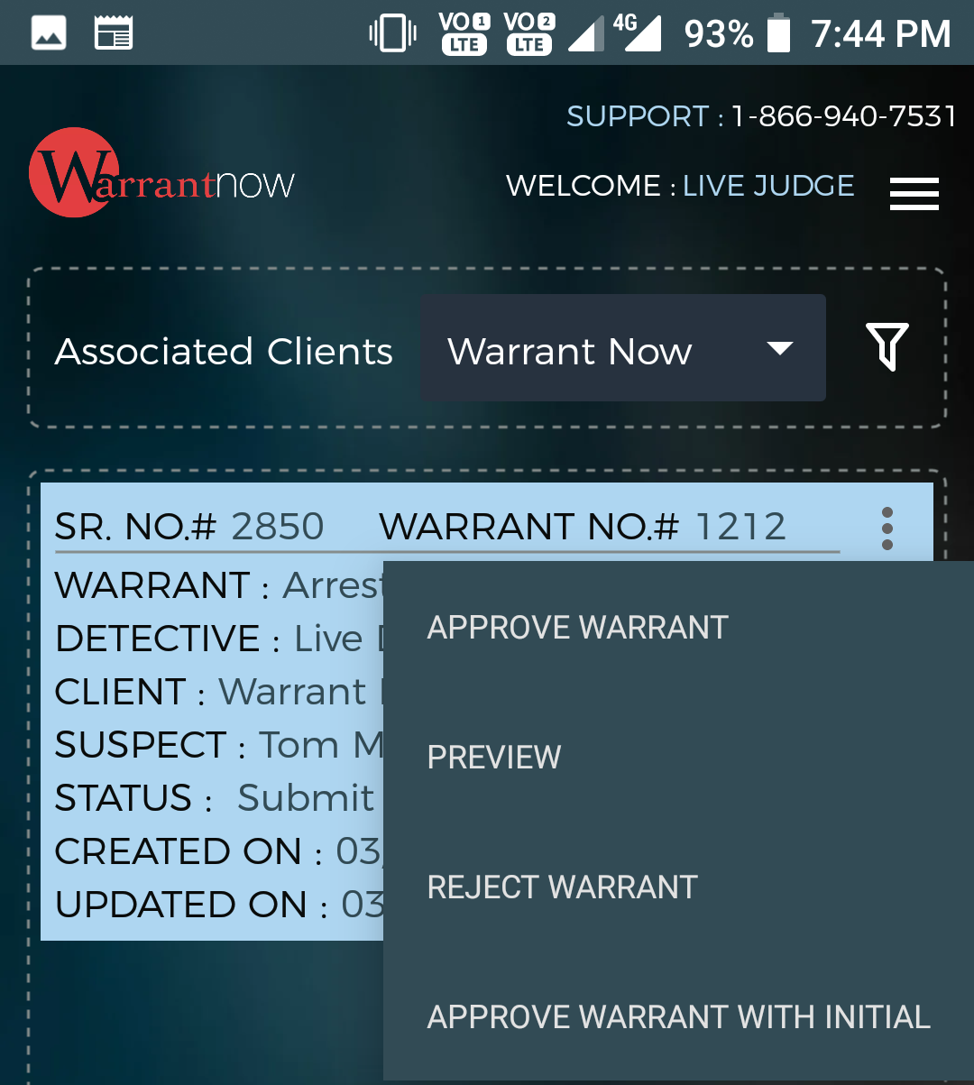
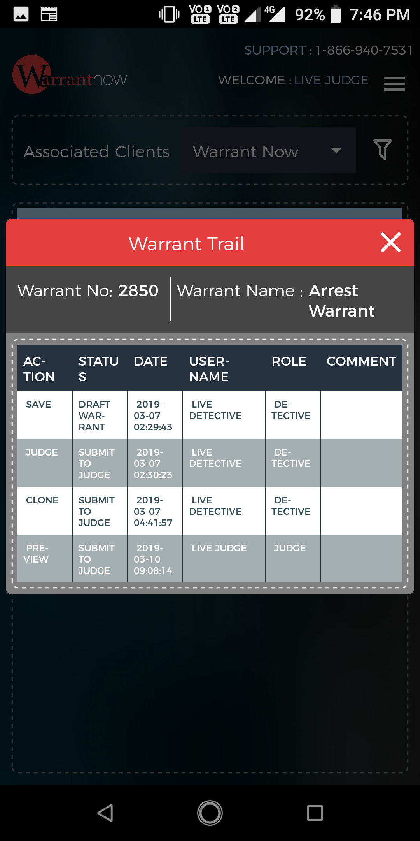

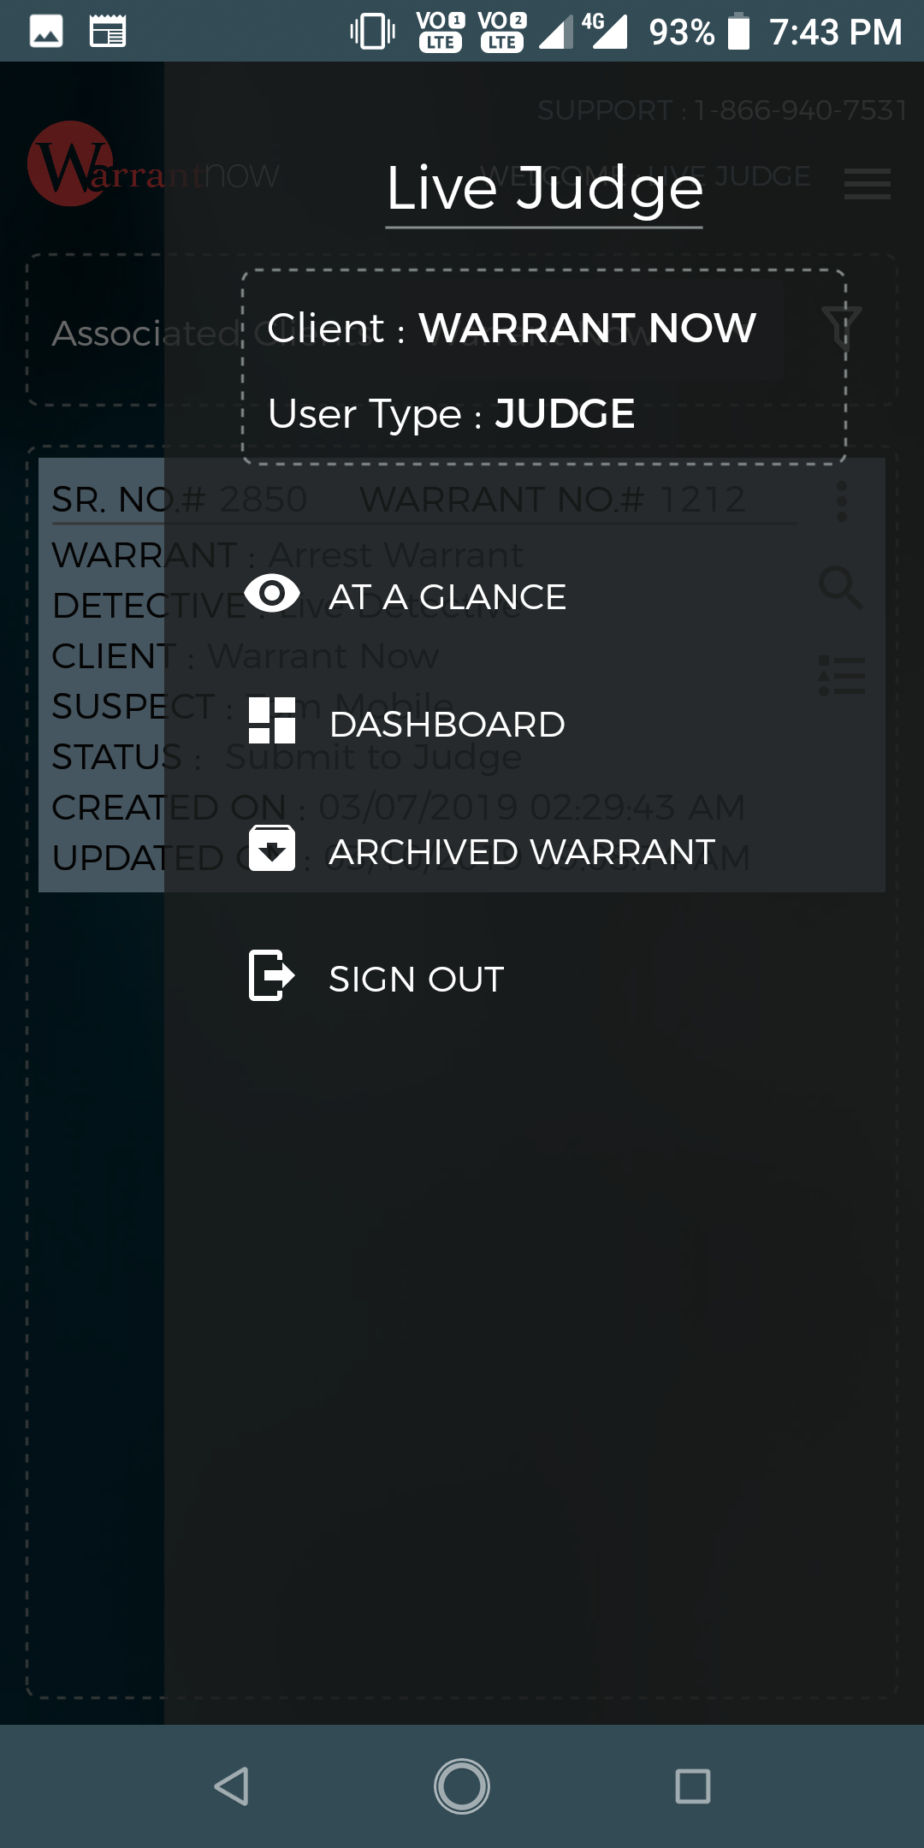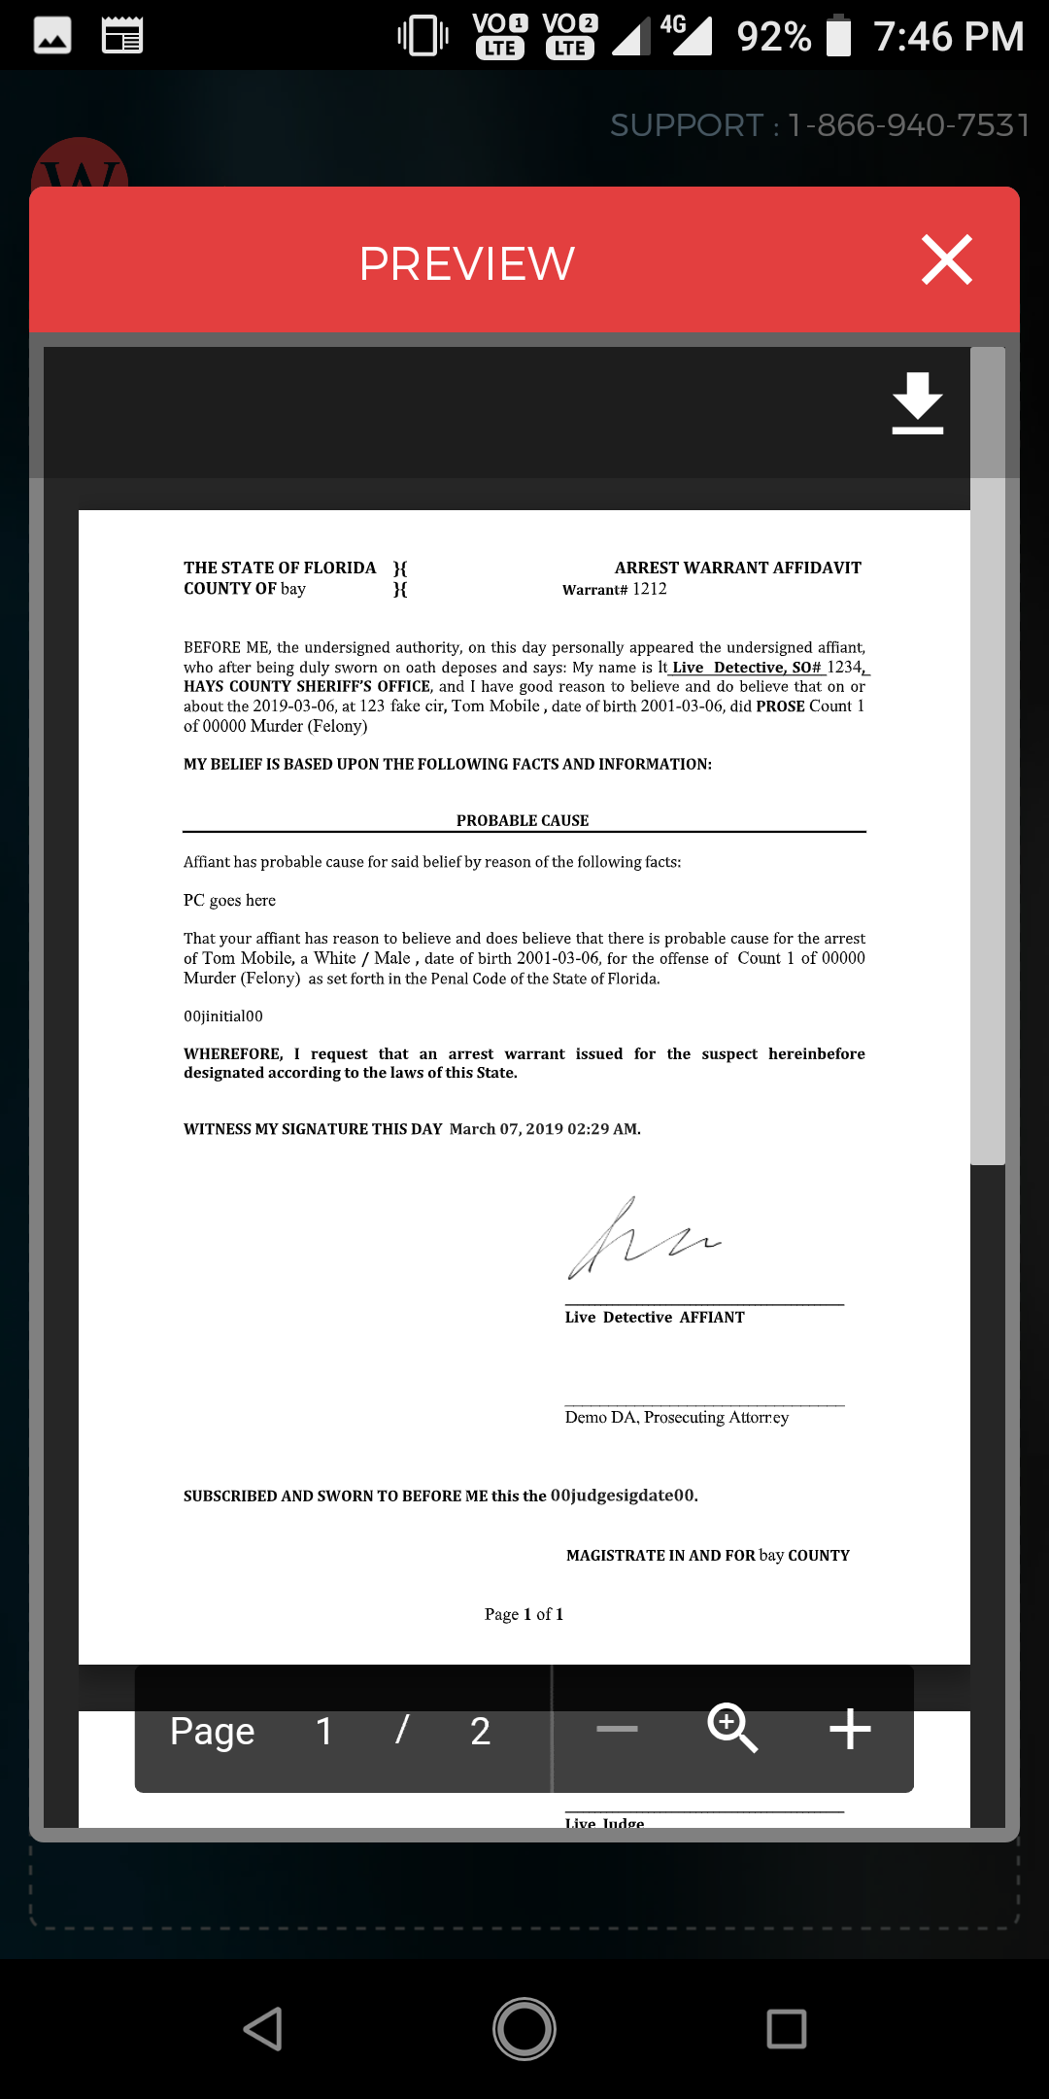
Preview
Printable/ Downloadable Warrant in doc format

Menu
Warrant Trail
It shows every action of a warrant
Action list
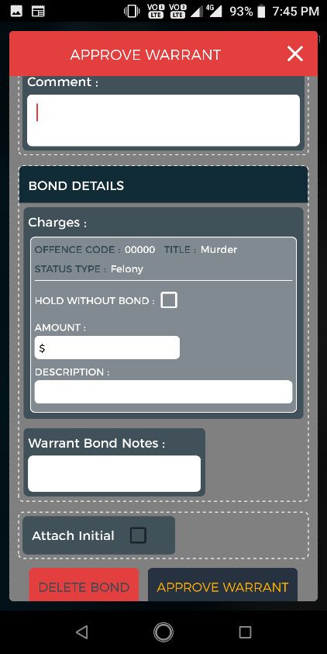
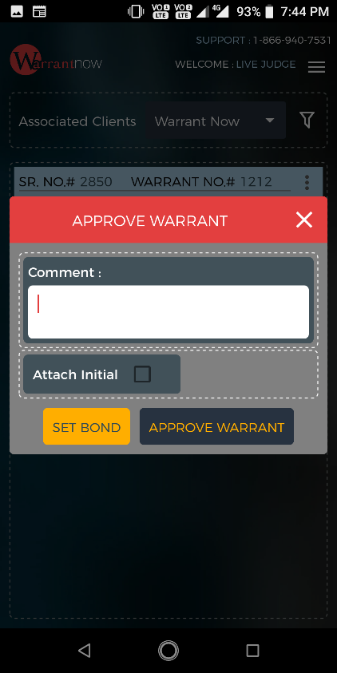
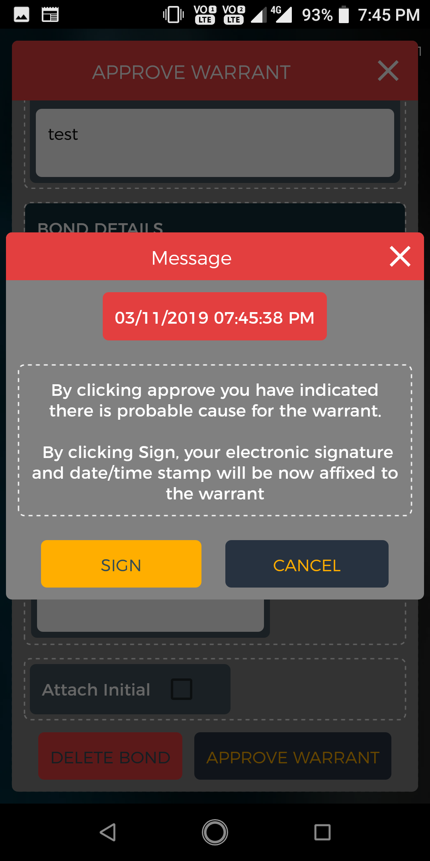Approve Warrant
Screen 3
Screen 1
Click on Approve Warrant from action menu shows this screen 1.
If user click on ‘Set Bond’ then Bond Details section will show (Screen 2) and Click on ‘Delete Bond’ the Bond Details section will hide.
Clicking on ‘Approve Warrant’ will show a message (Screen 3). If user click on Sign then the warrant will be approve and show an approval message. Clicking on Cancel will close the message.

Screen 2

Reject Warrant
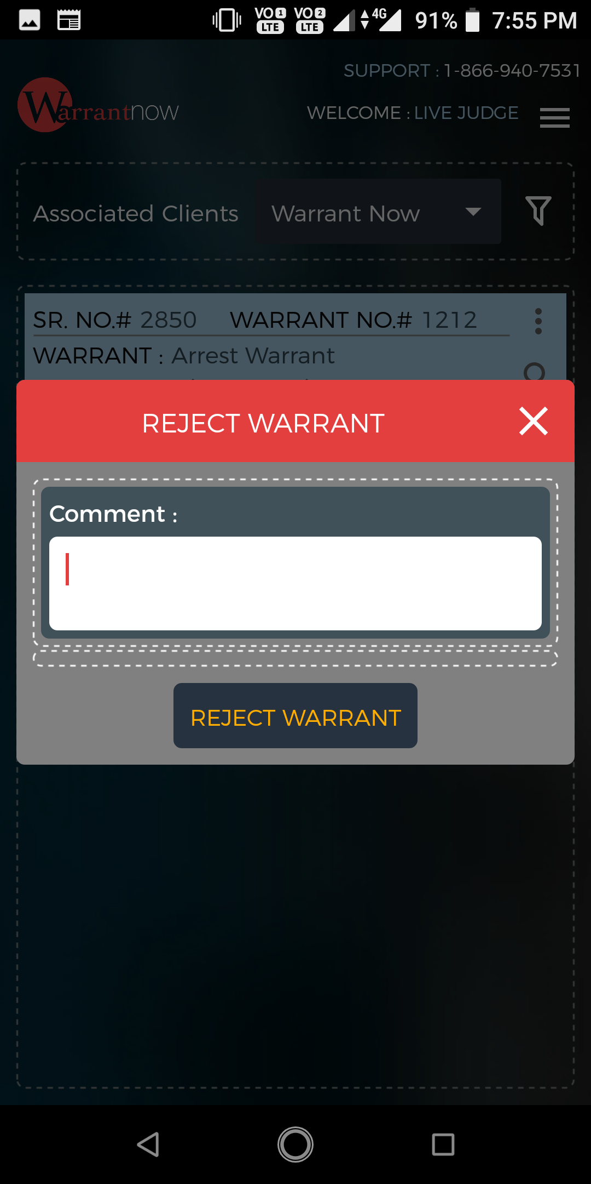

Click on Reject Warrant from action menu shows the above screen.
Clicking on Reject Warrant button will reject the warrant.

Approve Warrant With Initial
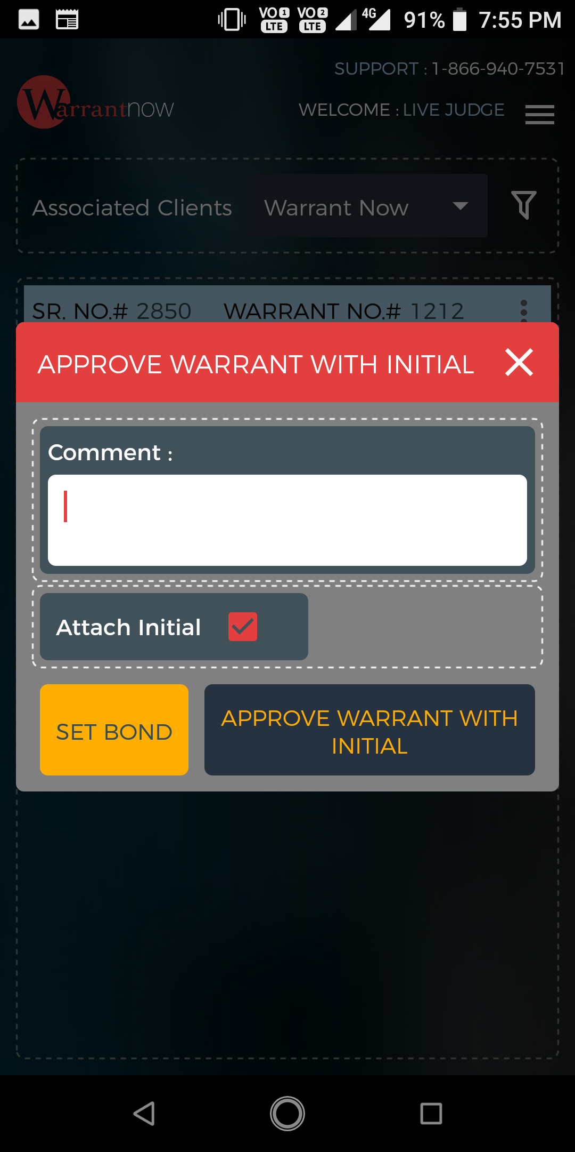

Clicking on Approve Warrant with Initial from action menu will show above screen
By default Attach initial check box mark as checked.
Set Bond and Approve Warrant with Initial button functionality same as Approve warrant.

Archive Warrant
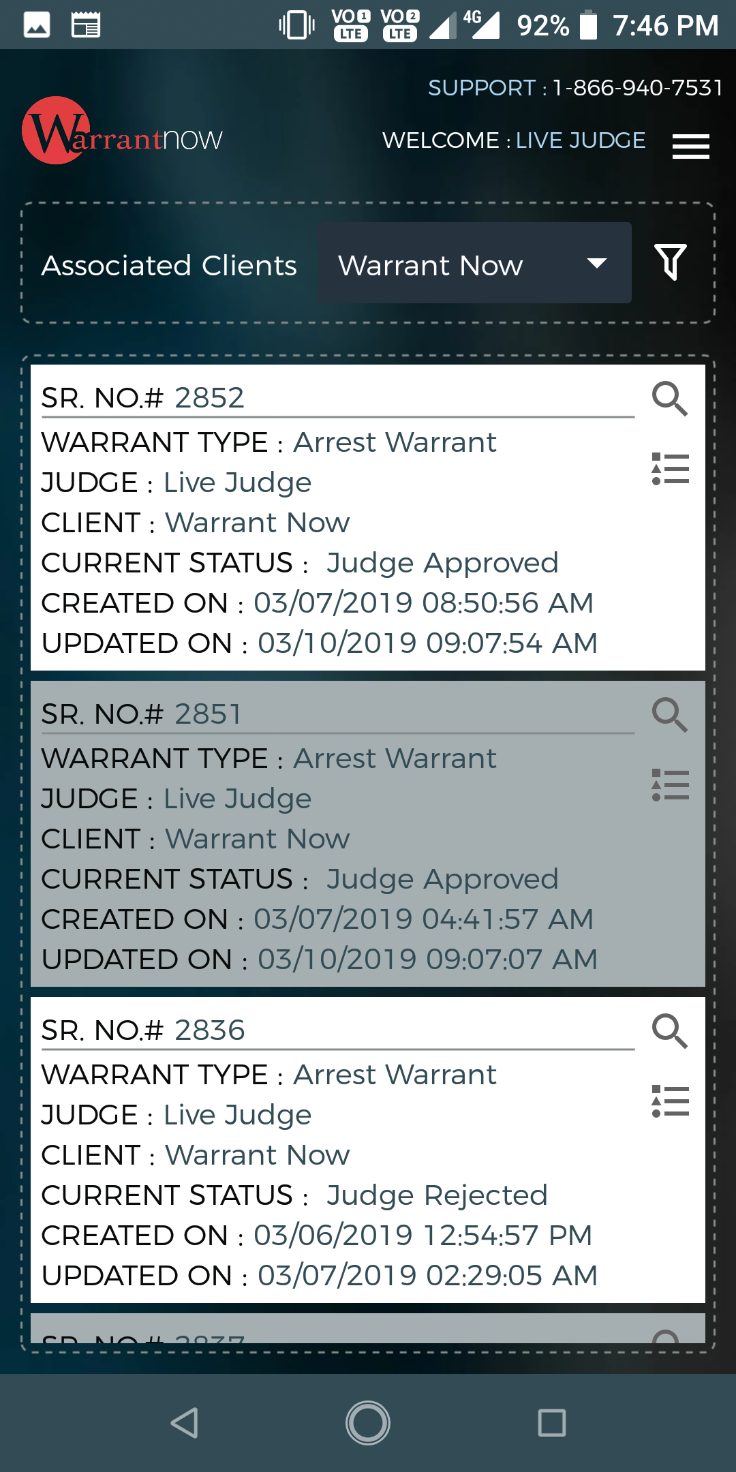
Archived warrant list
Warrant Trail
Preview
At a Glance
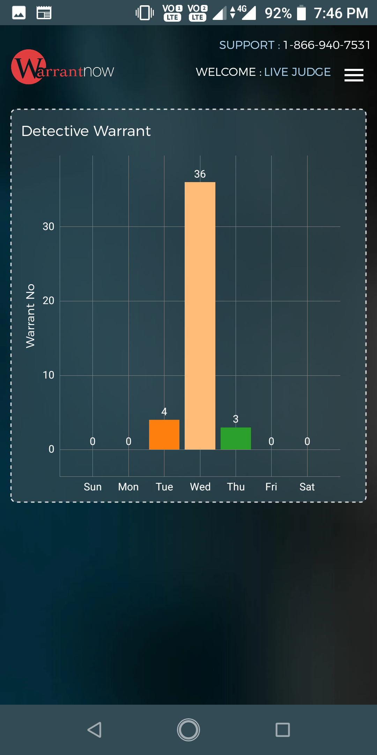
This section gives statistical information about warrant status, Warrant detail etc. by various charts (If data is not available then chart will not show).

